Titan Missile Museum
Titan missile complex 571-7, located roughly 25 miles south of Tucson Arizona ( 31°54'N 111°00'W), remains as the last of it's kind. In 1987 all Titan missile complexes were taken off alert and all but 571-7 were destroyed. The Pima Air & Space Museum leases the 571-7 complex from the Air Force and operates it as a Museum. On April 6, 1994 the museum was designated a national historic landmark.
NOTE: Last updated 11-4-98. This page is still being developed.
This page has 100K of images to load so please be patient!
The small photos are limited to 135 pixels wide, medium to either 640 wide or 480 tall, and large are the original or slightly cropped 1024x768 versions. All photos were taken with an Olympus 500L digital camera.
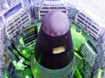 | Images: Small Medium Large  The Warhead  The re-entry vehicle, which contains the nuclear warhead, is the black portion of the missile. The light colored portion at the top of the missile is an ablative heat shield for the re-entry vehicle. This heat shield is similar in composition and function to those used by pre-Shuttle NASA manned space craft.  To convince the Soviets that this site was not active and would never again be active several modifications to the complex were necessary. The hole cut in the warhead was made to demonstrate that this is not a real warhead.  The grid like structures on the walls of the silo are retracted work platforms which can be lowered to give easy access to the missile.
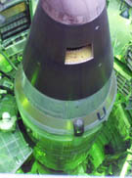 | Images: Small Medium Large  The Missile  The Titan II missile stands in a 146 foot deep silo. Work platforms, shown deployed to the left, were used to give missile crews access to the missile for fueling and maintenance. A mannequin can be seen on the far left. It not only demonstrates the use of the work platforms but also gives a sense of scale.
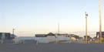 | Images: Small Medium Large  Top Side  The above ground portion of the complex consists almost entirely of the 740 ton silo door. The door has been left half open and concrete blocks have been placed to prevent the door from opening fully. This too was needed to keep the Soviets happy. As seen in the photo, the door is angled so that any debris covering or surrounding the silo could be cleared away by opening the door.  The museum has added several exhibits to the surface, some of which can be seen in this photo. The site would otherwise have been totally clear.
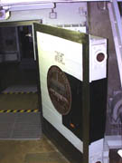 | Images: Small Medium Large  Outer Blast Door  After passing through the complex gate, after descending down the main access stairwell, and after descending 35 feet below ground you reach the outer blast door.
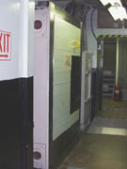 | Images: Small Medium Large  Inner Blast Door  The blast doors were electronically configured to prevent both doors from being open at the same time. When personnel were entering or leaving the complex they would have to enter a small space between the blast doors and close the door behind them before they could open the next door and proceed through.
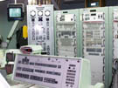 | Images: Small Medium Large  The Control Room  At a location 200 feet away from the missile silo, and 35 feet underground, a three story building contains the main control room and crew living quarters.  The closed circuit TV seen to the left is connected to a camera that is located in the main access stairwell. It was used as part of the strict security protocol used to control access to the missile complex.
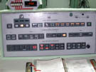 | Images: Small Medium Large  The Launch Control Console  The complex commander's console shows summary information and control for three areas:  - Launch  - Readiness  - Facilities  In the middle of the top row in the photo you can see the commander's launch key.
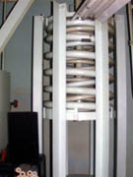 | Images: Small Medium Large  Springs  The three story structure that contains the main control room and crew quarters is suspended by large springs. The florescent light in the upper right of the photo gives a good sense of scale. Every aspect of the missile complex was shock mounted and isolated from the surrounding earth. This was done to allow the complex to survive a large earthquake or a near hit by a nuclear bomb.
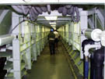 | Images: Small Medium Large  The Cableway  This 200 foot long passageway connects the control center to the missile silo. Like the rest of the complex it is suspended and shock mounted. You can see shock absorbers in the foreground and along the length of the passageway on each side. You can also see how the cables, on the left and above, were installed with slack. This allows for great movement of the passageway without breakage. This passageway is really just a bridge suspended inside a tunnel.
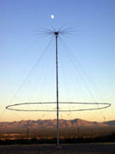 | Images: Small Medium Large  Wide Band Antenna  This large antenna is designed to be used for a wide range of frequencies. It would allow missile crews to receive instructions on alternate frequencies in the event that other frequencies were jammed or otherwise unavailable.
External Links:
- Official Pima Air & Space Museum's web site.
- Official Titan Missile Museum web page
- Bureau of Atomic Tourism
Back to the NuclearWinter.com home page.

